SYSTEM OPERATIONAL REQUEST: #2023-5

Walla Walla District

The following State, Federal, and Tribal salmon managers have participated in the preparation and support this SOR:

TO:
Corps of Engineers Northwestern Division (NWD)
WALLA WALLA DISTRICT (NWW)
TO:
COL Geoff Van Epps | COE-NWD-ZA Commander
LTC ShaiLin KingSlack  Beth Coffey | COE-NWW Commander  COE-NWD-PD
Brad Thompson | COE-NWD-PDD Chief
Steven Barton | COE-NWD-PDW Chief
Tim Dykstra | COE-NWD-PDD
Julie Ammann  Doug Baus | COE-NWD-PDW-R  COE-NWD-PDW-R
Aaron Marshall | COE-NWD-PDW-R
Lisa Wright | COE-NWD-PDW-R
Jon Roberts | COE-NWW-EC-H
Chris Peery | COE-NWW-OD-T
Jennifer Carrington | USBR-PN Regional Director
Jennifer Johnson | USBR-PN-6208
Joel Fenolio | USBR-PN-6204
John Hairston | BPA Administrator
Birgit Koehler | BPA-PG-5 (acting)
Scott Armentrout | BPA-E-4
Leah Sullivan | BPA-PGB-6 (acting)
Alex Kay | BPA-PGPO-6
Tony Norris | BPA-PGPO-6
Scott Bettin | BPA-EWP-4
Tribal Liaisons: Dean Holecek (NWD)

FROM: Thomas Lorz, FPAC chair

DATE: July 25, 2023

SUBJECT: Requested temporary change to Lower Granite Dam tailrace water temperature criteria to provide Dworshak summer flow augmentation through 31 August

SPECIFICATIONS: If needed to achieve the Dworshak Reservoir elevation threshold of 1535 ft on 31 August, relax the temperature criteria from 68°F to 69°F maximum in the Lower Granite tailrace, with the intent not to exceed 69.5°F. The increased temperature threshold could occur between 06-14 August 2023.
JUSTIFICATION:
Dworshak reservoir filled by the beginning of July 2023, but low summer inflow to the reservoir and consistent high air temperatures have reduced flexibility to react to extended heat waves while drafting to currently agreed to Dworshak Reservoir elevation threshold of 1535 ft by 31 August. Current projections suggest the remaining summer flow augmentation volume is sufficient to maintain the Lower Granite Dam tailrace at or below 68°F if there are no additional extended heat waves requiring flows above powerhouse capacity from Dworshak Dam (Walker 2023). Unfortunately, the 30 day forecast from the National Oceanographic and Atmospheric Administration Climate Prediction Center suggests that higher than average temperatures are probable (Figure 1).

Depleting the flow augmentation volume from Dworshak Reservoir before 31 August threatens steelhead and fall Chinook passage in the Lower Snake River and above Lower Granite Dam, Snake River fall Chinook salmon hatchery broodstock collection at the Lower Granite Adult Trap, and Nez Perce Tribal Hatchery (NPTH) operations during late August. Fall Chinook salmon broodstock collection typically begins 17 August and requires temperatures at the Lower Granite Dam adult fish trap to be below 70°F and ideally below 68°F. The potential to ramp down to minimum discharge from Dworshak Dam during the last week of August threatens trapping operations at the Lower Granite Dam Adult Fish Facility due to fish health related temperature restrictions while causing undue stress on trapped fish. More importantly, reduced flow from the North Fork Clearwater River reduces the extent of cold water refuge immediately above Lower Granite Dam. Any additional days gained through Dworshak Reservoir water conservation for release during the end of August will benefit steelhead passage, fall Chinook passage, fall Chinook hatchery broodstock collection efforts, and ensure lower Clearwater River temperatures are at or below 66℉ needed for NPTH operations and provide cold water refuge.
Allowing the temperature of the Lower Granite Dam tailrace to reach 69°F, but not exceed 69.5°F for 6 days may extend summer flow augmentation from Dworshak Dam from 28 August to 31 August (Walker 2023) and not force early depletion of water managed under the Nez Perce Agreement. If there is a gap between summer flow augmentation and Nez Perce Agreement water volume, the Lower Granite tail water temperatures may reach 71-74℉, which can be lethal for migrating salmonids that have already accumulated significant thermal stress lower in the Columbia River.
We acknowledge that temporarily increasing the temperature creates a more stressful environment for adult sockeye salmon, adult summer steelhead, and juvenile and adult fall Chinook salmon migrating during the specified period. Yet, the proportion of each species migrating from 06 -15 August is low (Figure 2) relative to the proportion of runs migrating from 28 August – 01 September. Furthermore and unfortunately, the last quartile of the Snake River sockeye arriving at Lower Granite Dam experiences much lower survival from Lower Granite Dam to their natal area in a typical year than earlier migrants (Johnson et al. 2019, 2020, 2021; Crozier et al 2020) due to thermal stress accumulated between Bonneville Dam and Lower Granite Dam as well as high water temperatures in the Snake River and lower Salmon River in August. As such, increasing the temperature target for the Lower Granite Dam tailrace in the beginning of August is unlikely to impact the Snake River sockeye salmon population as a whole.

References:

Crozier, L. G., J. E. Siegel, L. W. Wiesebron, E. M. Trujillo, F. J. Burke, B. P. Sandford, and D. L. Widener. 2020. Snake River sockeye and Chinook salmon in a changing climate: Implications for upstream migration survival during recent extreme and future climates. PLoS One. https://journals.plos.org/plosone/article?id=10.1371/journal.pone.0238886

Johnson, E., K. Plaster, C. Kozfkay, and J. Powell. Snake River sockeye salmon captive broodstock program: Annual progress report January 01, 2017 - December 31, 2018. IDFG Report Number 19-05.

Johnson, E., K. Plaster, Z. Nemeth, and J. Powell. 2020. Snake River sockeye salmon captive broodstock program: Annual progress report January 01, 2019 - December 31, 2019. IDFG Report Number 20-07.

Johnson, E., K. Plaster, Z. Nemeth, and J. Powell. 2020. Snake River sockeye salmon captive broodstock program: Annual progress report January 01, 2020 - December 31, 2020. IDFG Report Number 21-10.

Walker, W. 2023. Presentation to Technical Management Team July 19, 2023. https://pweb.crohms.org/tmt/agendas/2023/0719_Dworshak-Alternative-Operations.pdf

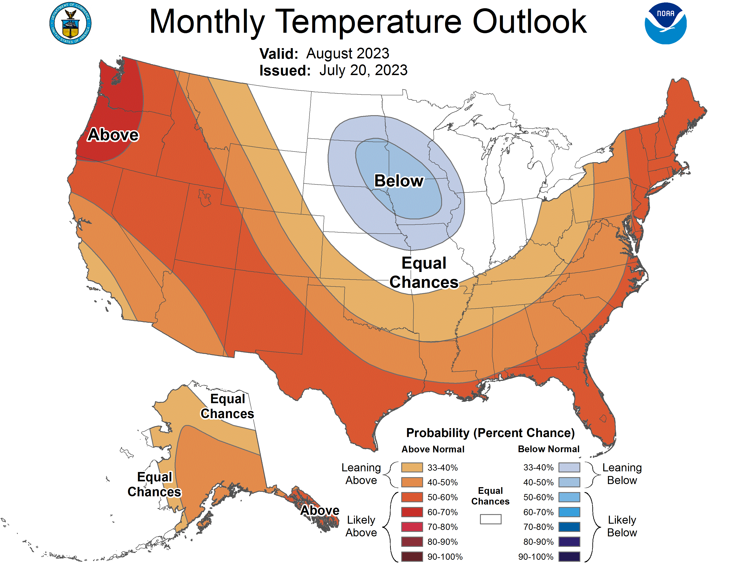

Figure 1. Monthly temperature outlook from the NOAA Climate Prediction Center (viewed 21 July 2023).

Figure 2. Ten-year average daily proportion of Sockeye Salmon, Chinook Salmon, and Steelhead runs counted at the Lower Granite Dam counting station for the 2013-2022 period. Window counts were obtained from DART. Proportion reflects total passage from 15-Jun – 31 December. The relaxed temperature criteria described in this SOR could occur in the orange box (August 06-14) unless coordinated otherwise. The red box shows when Dworshak water may not be available if the SOR is not implemented. The vertical black line shows the date fall Chinook salmon broodstock collection begins. Chinook salmon are counted as fall Chinook at Lower Granite Dam after August 15 and therefore, the proportion of window count classified fall Chinook salmon impacted by the operation is zero; however, genetic sampling and visual identification of Snake River fall Chinook demonstrate that fall Chinook do arrive at Lower Granite Dam prior to August 15. For simplicity, we included both summer and fall Chinook Salmon in the proportions.

