2023 Chum Spawning Operation

Grand Coulee was filled to elevation 1286 feet by October 31 to prepare for the start of the chum operation on November 1st. As coordinated at TMT the start of the spawning phase of the chum operation began on November 1 targeting a lower tailwater range of 10.3-11.2 feet in the early days of chum arrival for the purpose of reducing a forecasted substantial draft of Grand Coulee.
Since the operation was coordinated local conditions improved significantly. Westside precipitation increased the flow in Hamilton Creek and Springs by Friday November 3rd such that any early arrivals would have access to the creek and conditions conducive to spawning in the Ives Channel immediately below the mouth of Hamilton Creek.

On a site visit by Tony Norris, BPA on Friday, November 3rd no chum were observed in Hamilton Springs but spawning activity was observed in the riffle below Hamilton Springs. This area had significant flow and Tony was too far away to be able to observe if they were chinook or chum but the PSMFC monitoring crew have seen chum spawn in this location in the past. Two to three Chum were observed building redds immediately below the mouth of Hamilton Creek in Ives Channel in a location that is a typical spawning area. One chum was observed transiting from Hamilton Creek back downstream to the Ives Channel. On this trip we spoke with Rick Heitz, PSMFC who noted that they had observed chum spawning at McCord Creek on a previous day.
On a site visit on Monday, November 6 with Kelsey Swieca, NOAA and Charles Morrill, WDFW we observed at least ~20 chum in Hamilton spring and several chum in the Ives Channel area. Tailwater elevations, Tanner Ck gauge were between 10.7 and 10.8 perhaps a bit higher (See Project Data page 5). We spoke with the chum monitoring crew as they walked through this area and they passed on to us that several chum were observed spawning in the other usual places at Woodard Creek, McCord Creek and on the Breaks. The conditions observed were significantly higher flow rates out the Hamilton Springs and Creek than the previous site visit 3 days earlier. The flow from Hamilton Creek was high enough to back water into the pool above Hamilton Creek along Hamilton Island upstream of the mouth of Hamilton Creek. It appeared that there was sufficient water for adult salmon to transit into and out of the pool. The Hamilton Creek gauge (#14128895) reading was roughly 22.7 feet.

On this trip we discussed the significantly improved water management condition primarily due to the change to a wetter local pattern and improved streamflows. As a result of the change in conditions Grand Coulee had already filled a few tenths in the first few days of the chum operations and was expected to either pass inflow or continue to fill.
Additionally, forecasts for the expected draft of Grand Coulee to support the more typical chum spawning tailwater operation of 11.3 – 13 feet had now improved.
Considering, that the operation to date had achieved the objective of minimizing the draft of Grand Coulee and current forecasts were not seeing the dramatic impact to Grand Coulee elevation through November and December NOAA and WDFW agreed that it was prudent transition to the more typical chum spawning tailwater range.

The operation coordinated was to move to the typical chum spawning tailwater range of 11.3 to 13.0 feet no later than Thursday, November 9. Communication of the change was made via phone to several of the Salmon Managers while we were the in the field.

As of Thursday, November 9 the Bonneville tailwater elevation had reached 11.6 feet and Grand Coulee’s forebay elevation was at elevation 1286.7 feet. Current forecasts indicate that Grand Coulee is expected to draft to support the operation but likely to remain at or above elevation 1283 feet by Mid-November and end December at or above elevation 1280 feet.

2023 - 2024 Bonneville Chum Operations

260

240

220

200

180
-
26.0

24.0 -
22.0 --=
C:
^{20.0} ·0..:;

vi' 160
-u

140

18.0
ra
>
LI.I
....

120
0
16.0 "-
(I.I
14.0 ra

u:::: 100
80

60

40

20

0
0 8 8 0

12.0
z
10.0 0
C0
8.0

6.0
0 0

9. 0 0
0
9. 0 0
0 0 0

m m m
N N N
;;,- ,--< 0:,
---- ----
N -;::;- -;::;-
C) ,--< ,--<
,--<
-BON.Flow-Out.Ave.~1Day.1Day.CBT-REV
--PRD.Flow-Out.Ave.-1Day.lDay.CBT-REV
--MCN.Flow-Out.Ave.~10ay. lDay.CBT-REV
-- BON.Elev-Tailwater.l nst.1Hour.O.CBT-REV
- Chum Spawning End Date
m m
N
s s
;;,- N

M ,--<
-- BON.Flow-Out.Ave.1Hour.1Hour.CBT-REV
--IHR.Flow-Out.Ave.~1Day.1Day.CBT-REV
--SLMO.Flow.lnst.0.0.MIXED-COMPUTED-REV
- Chum Spawning Start Date
- Chum Protection End Date
m
eNn
N
,--<
----
,--<

2023 - 2024 BON TW and GCL FB

--= 1,288.0
-
OC: 1,287.0
·..:;
1,286.0

LI.I 1,28S.O
r>a

26.0

24.0
22.0 --=
C:
^{20.0} ·0..:;
ra
18.0 >
w
16.0 "-
....
(I.I

.C 1,284.0 +--------- ------------------------------------+ 14.0 ra
(I.I
i"£­

.u..I
C,
1,283.0

1,282.0

1,281.0

1,280.0

0 0 0 0
9. 0 0 9.
0 0 0 0
m m m m
N N N N
0 0 0 0
N N
;;,- ,--< 0:, ;;,-

0
9.
0
m
N
0
eNn
12.0

z
10.0 0
C0
8.0

6.0

N ,--<
-;::;- ,--< N

C)
,--<
-, <-

,--<
-;::;-
,--<
-;::;-
,--<

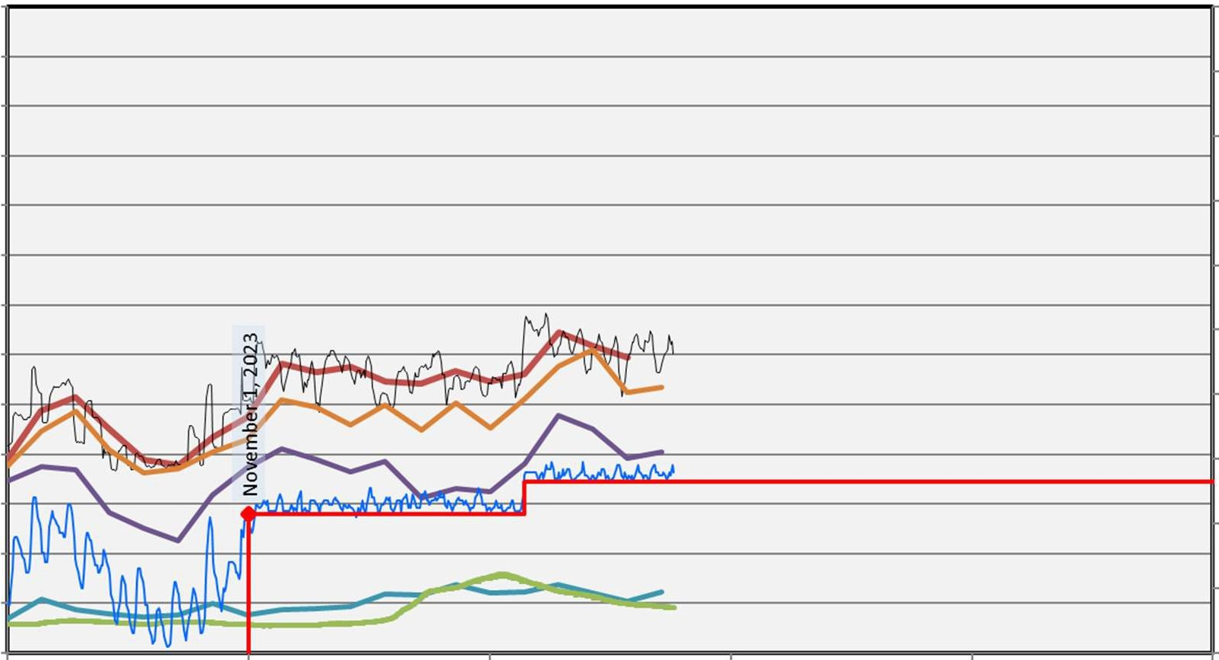
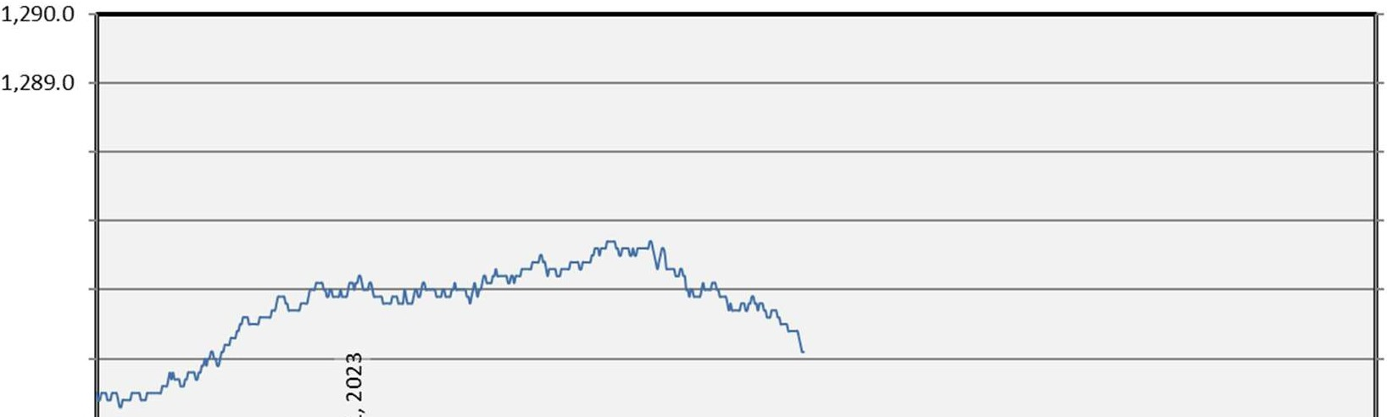
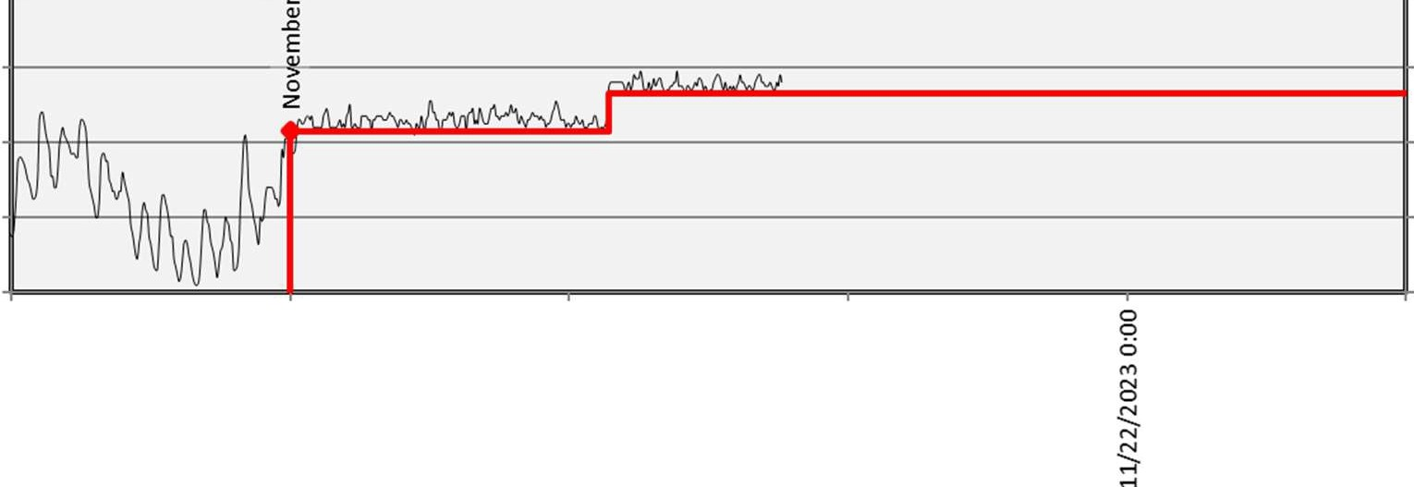
--GCL.Elev-Forebay.lnst.lHour.O.CBT-REV

- Chum Spawning End Date
-- BON.Elev-Tailwater.lnst.lHour.O.CBT-REV

- Chum Protection End Date
- Chum Spawning Start Date

--Chum TW Lower Contraint

Mouth of Hamilton Creek on Friday November 3rd.
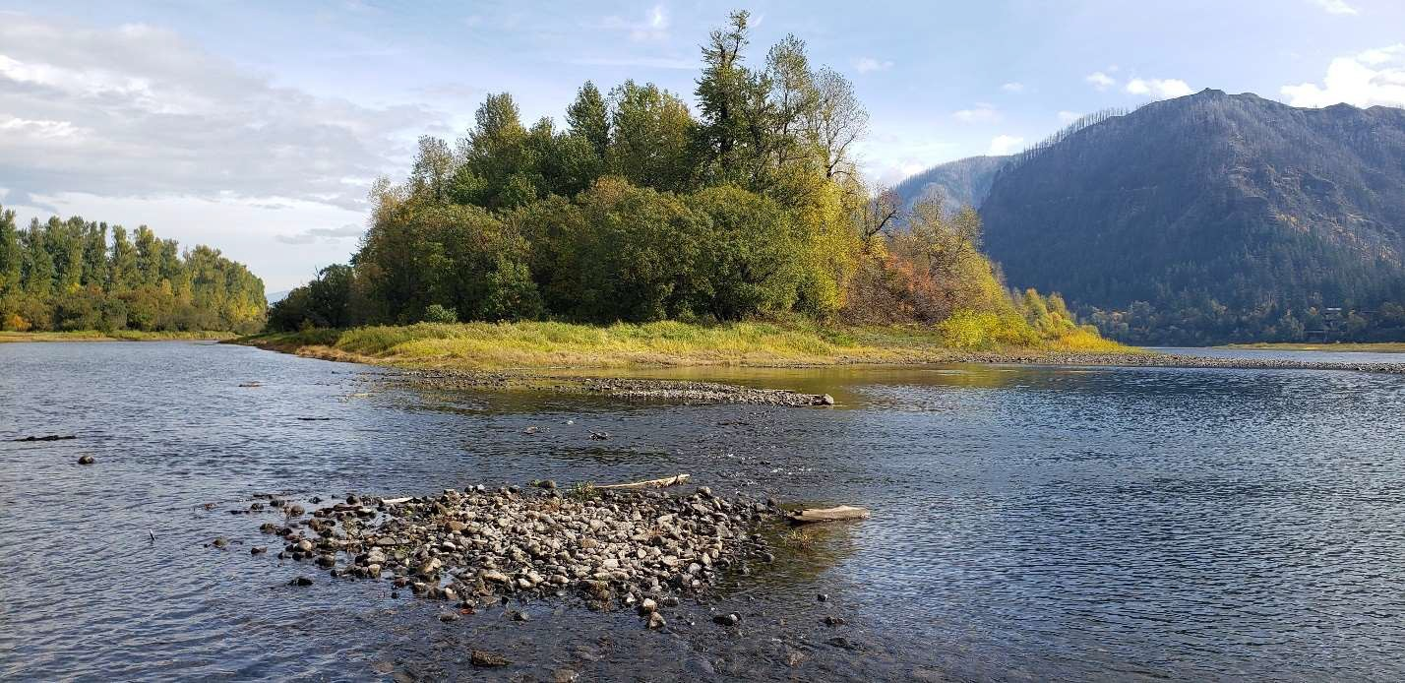
Looking upstream at Ives Channel toward the mouth of Hamilton Creek Friday November 3rd. The pools of water in the foreground is groundwater expressing above the upstream and downstream water surfaces indicating that the typical groundwater conditions are present.
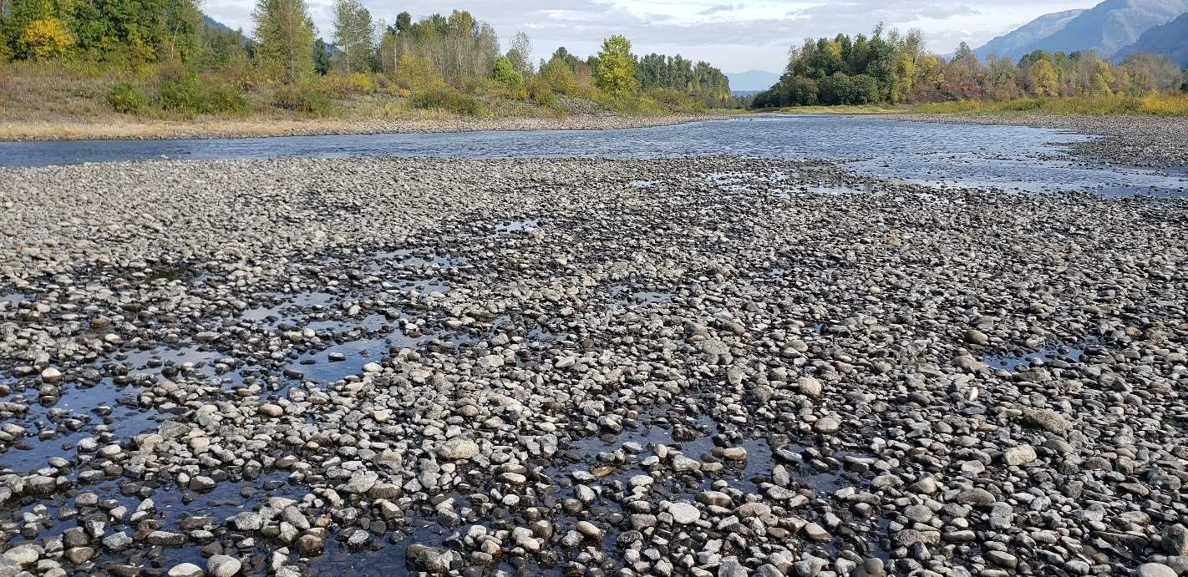

Looking Downstream at the break in slope at the mouth of Hamilton Creek on Monday November 6.
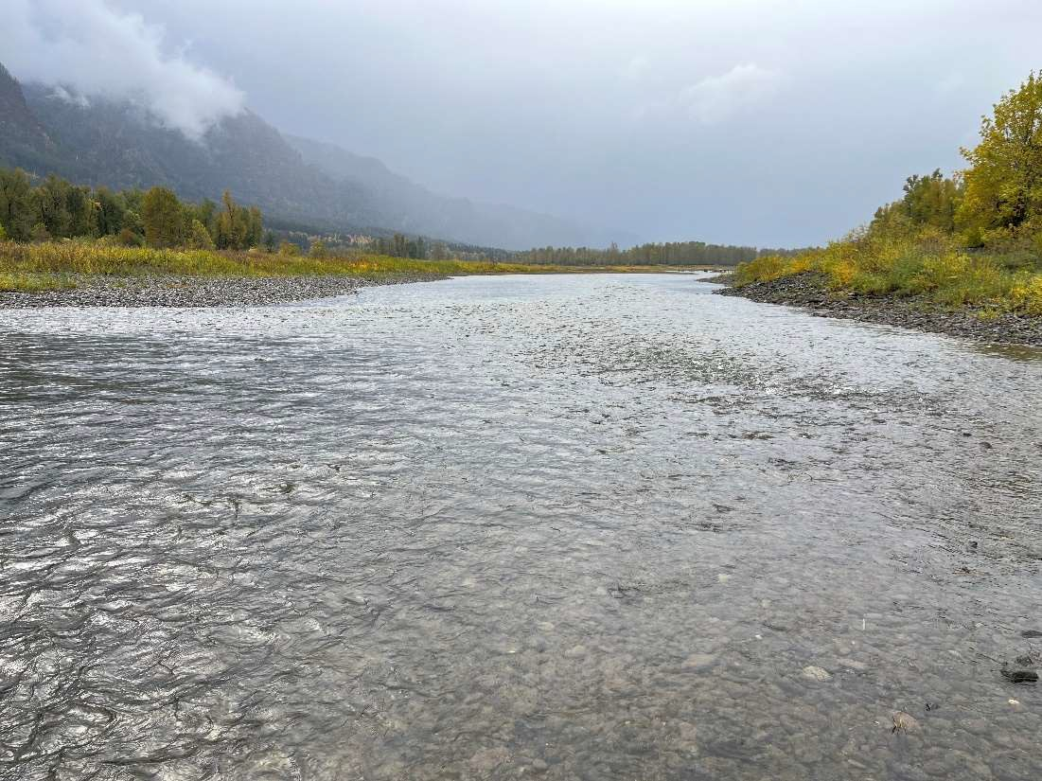
Looking upstream from just downstream of the mouth of Hamilton Creek.
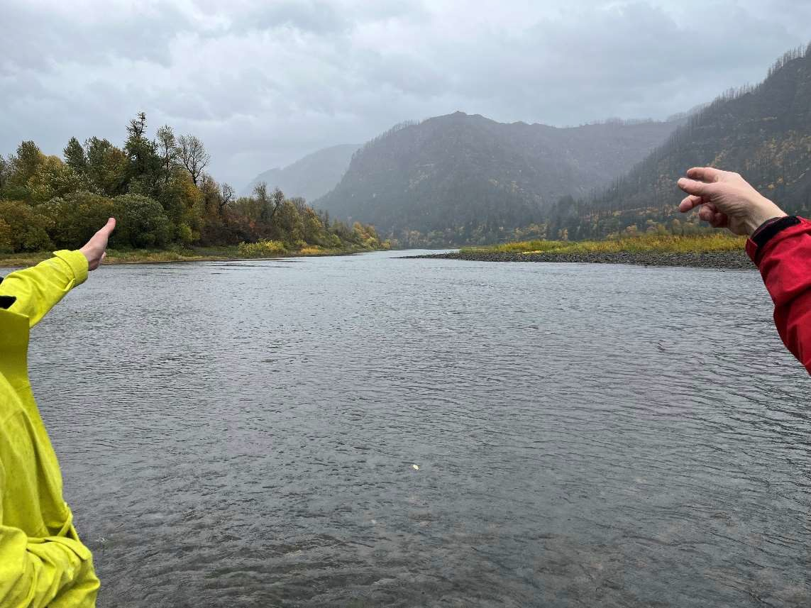

Tailwater Elevations, Tanner Ck Guage, Nov 6, 2023

Hamilton Creek Gauge
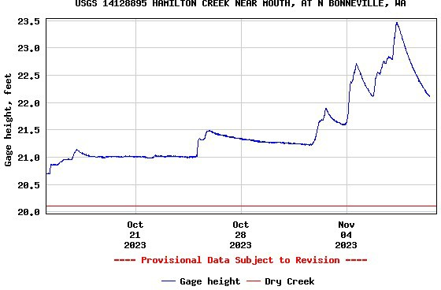
Grand Coulee forebay elevation 2002-20222. All but a few years end December above elevation 1280 feet. Current forecasts show a similar range of outcomes.
