ERDC Spill Pattern Updates

Bonneville

Week of July 10th, 2017 and July 17th, 2017

OBJECTIVES: Court Order to spill to Gas Cap. Need to define what that looks like for each project and identify constraints. Note: No anticipated issues are expected except with the potential of rock movement into the stilling basin.

ASSUMPTIONS: Voluntary spill patterns over the past few years have provided acceptable fish passage conditions. The physical model will be observed at voluntary spill pattern levels closest to the desired change. Differences from the “acceptable” will be noted.

Bonneville:

Fish Passage Concerns/Issues

* Will the existing spill pattern provide good juvenile egress at all tailwaters? (Note gas cap will involve higher spill volumes at lower tailwaters.)
* Are shore line velocities too high for good adult passage?
* Is flow off the 14 foot or 7 foot deflectors an issue for the specific TW?

Integrity of the Structures (spillway, channel slopes, fish ladder, etc)

* Velocities high enough on the shoreline to cause erosion?
* Will rocks move into the stilling basin at lower Qs and lower tailwaters?

July 10th – Travel Day for NWP team members

Ida Royer

Jon Rerecich

Amy Lynn

Laurie Ebner

July 11th

8 AM Check in at PAO

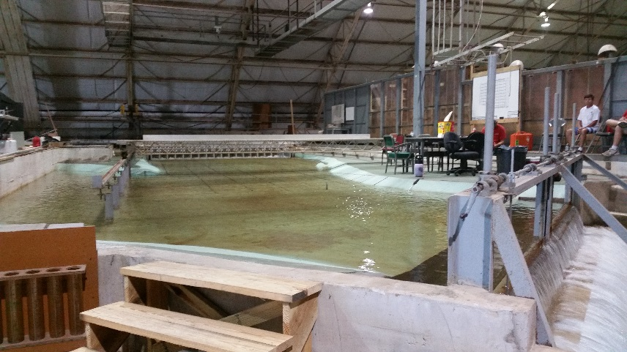

**Photo 1 – Bonneville 1:55 Spillway Model**

8:30 AM Meet at Bonneville 1:55 Spillway Model

Develop test metrics to be used in all following tests for determining conditions that have good passage.

Metrics were developed at:

Test 1 - 100 Kcfs 21 feet TW

Test 2 - 125 Kcfs 21 feet TW

Metrics developed: DYE

*2 ounces of dye released from a measuring cup onto the ogee in order to test water movement/egress out of the stilling basin and downstream

Released in bays 3 and 4

Released in bay 9

Released in bays 15 and 16

*A wand released along the 400 foot transect starting at bay 18 and moving across to bay 8 to test water movement/egress from location downstream of stilling basin and out

Metric developed: VELOCITY

Taken at the cross section at the 500 foot transect downstream of the 17/18 pier

Metric developed during previous modeling efforts: ROCKS

Rocks were placed at 300 foot transect downstream of pier 16/17 and monitored for movement via underwater video camera and draining water following model run to identify rock locations.

NOTES: Have picked up hardware from Home Depot to figure out a way to standardize dye release locations, volumes, and concentrations in the bays. Evaluated the device later part of this trip. Going to have ERDC take velocity measurements for selected conditions prior to September Regional Visit because a tripod would provide consistent results.

Bonneville Information:

Bonneville FPP Spill Pattern – an abbreviated version of the pattern is shown in Table 1.

Tailwater (see Table 2)

Bathymetric Data (see Attached Charts)

Juvenile and Adult Fish Passage Data

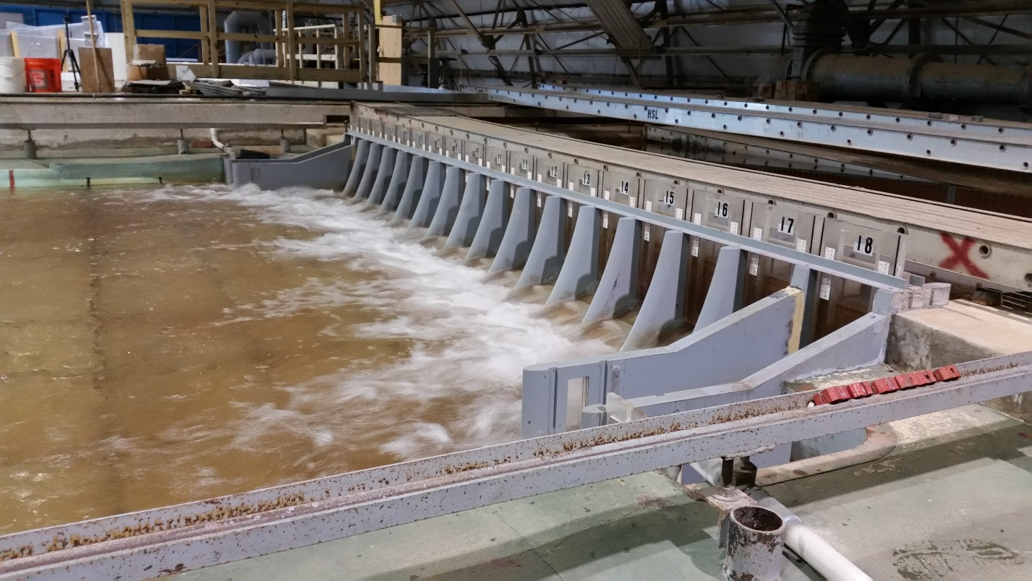

**Photo 2 Bonneville Spillway 1:55 Model**

**TEST: Spillway egress conditions using dye. Velocity also measured for each condition. Want ERDC to retake velocities measurements prior to the September Agency Trip.**

Conditions tested are below – test results are shown in Table 4. Green was considered good egress, yellow was okay, mauve questionable and red – dye never got downstream. Times are recorded in Table 4.

Test 3 Q = 100 Kcfs

3A – TW = 21 feet (Total River = 250 Kcfs)

3B – TW = 18 feet (Total River = 200 Kcfs)

3C – TW = 15 (Total River = 150 Kcfs)

3D – TW = 12.8 (Total River = 135 Kcfs)

3E – TW = 10 feet (Total River = 100 Kcfs) – tailgate would not allow us to get to this flow condition

Test 4 Q = 125 Kcfs

4A – TW = 21 feet (Total River = 250 Kcfs)

4B – TW = 18 feet (Total River = 200 Kcfs)

4C – TW = 15 (Total River = 150 Kcfs)

4D – TW = 13 (Total River = 135 Kcfs)

4E – TW = 10 feet (Total River = 100 Kcfs) – tailgate would not allow us to get to this flow condition

Test 5 Q = 150 Kcfs

5A – TW = 21 feet (Total River = 250 Kcfs)

5B – TW = 18 feet (Total River = 200 Kcfs)

5C – TW = 16.5 (Total River = 160 Kcfs)

July 12th

5D – TW = 24 (Total River = 300 Kcfs)

5E – TW = 29 feet (Total River = 400 Kcfs)

Test 6 Q = 175 Kcfs

6A – TW = 18 feet (Total River = 200 Kcfs)

6B – TW = 21 feet (Total River = 250 Kcfs)

6C – TW = 24 (Total River = 300 Kcfs)

6D – TW = 29 (Total River = 400 Kcfs)

Test 7 Q = 200 Kcfs

6A – TW = 18 feet (Total River = 200 Kcfs)

6B – TW = 21 feet (Total River = 250 Kcfs)

6C – TW = 24 (Total River = 300 Kcfs)

6D – TW = 26 (Total River = 350 Kcfs)

6E – TW = 29 (Total River = 400 Kcfs)

6F – TW = 30.5 (Total River = 450 Kcfs)

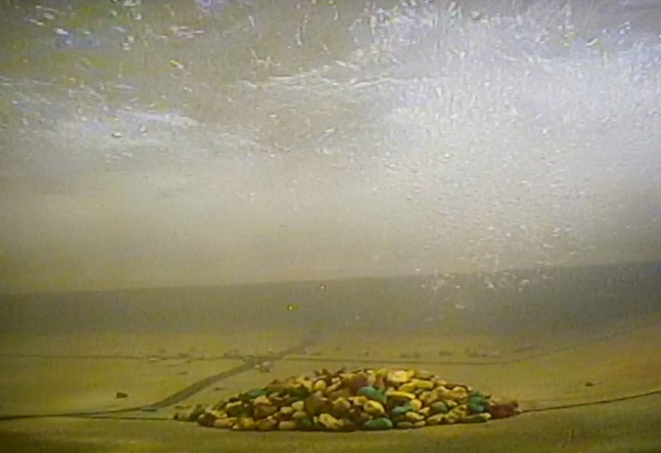

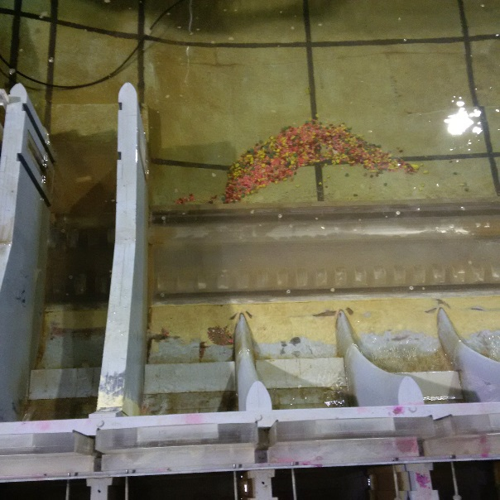

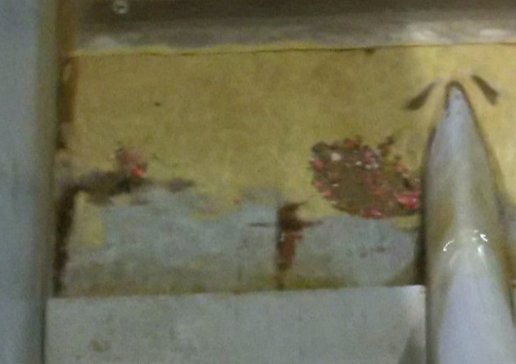

**Photos 3-5. TEST: Rock Movement Bonneville Spillway 1:55 model**

A pile of rock was placed at the 300 foot mark downstream of the 15/16 pier. If they moved at a specific tailwater more rocks were added. Test were short enough to verify rocks would move onto the ramp. Longer test were done later to figure out final resting place.

An underwater camera was set about 400 to 450 feet downstream of the rocks and rock movement is monitored.

Test 8 Q = 200 Kcfs

8A – TW = 30.5 feet (Total River = 450 Kcfs)

Minimal movement

8B – TW = 29 feet (Total River = 400 Kcfs)

Movement north

8C – TW = 25.5 feet (Total River ~ 350 Kcfs)

Movement up the ramp

Test 9 Q = 175 Kcfs

9A – TW = 24 feet (Total River = 300 Kcfs)

Rocks Move into stilling basin

9B – TW = 26 feet (Total River = 350 Kcfs)

Rocks moved but not real fast

9C – TW = 29 feet (Total River ~ 400 Kcfs)

Movement initiated but very slow. Would live with it.

July 13th

Test 10 Q = 150 Kcfs

10A – TW = 29 feet (Total River = 400 Kcfs)

Some movement when there should be none

10B – TW = 26 feet (Total River = 350 Kcfs)

Rocks moved

10C – TW = 24 feet (Total River ~ 300 Kcfs)

Rolling circus of rock movement

Test 11 Q = 125 Kcfs

11A – TW = 24 feet (Total River = 300 Kcfs)

Movement when there should be none

11B – TW = 21 feet (Total River = 250 Kcfs)

Some movement east towards bay 16/17

11C – TW = 18 feet (Total River ~ 200 Kcfs)

Some movement east towards bay 16/17

11D – TW = 15 feet (Total River = 150 Kcfs)

No movement

Test 12 Q = 100 Kcfs

12A – TW = 15 feet (Total River = 150 Kcfs)

No movement

12B – TW = 18 feet (Total River = 200 Kcfs)

Some movement east towards bay 16/17

12C – TW = 21 feet (Total River ~ 250 Kcfs)

Some movement east towards bay 16/17 and some movement north

Test 13 – Model runs of rock disposition over a longer run time. Rocks are placed at the 300 foot downstream of the 16/17 pier. Model is ran for 2 hours model time. Model is drained and we look at the disposition of the rocks.

13A – Spill 125 and TW of 24

Some of the rocks moved on to the ramp but very few moved up and into the stilling basin.

13B – Spill 150 and TW of 24

General movement east.

July 14th

13C – Spill 175 and TW of 24

Rocks moved to the apron. A dozen or so jumped into the stilling basin after 2 hours.

13D – Spill 175 and TW of 21

Rocks moved into the stilling basin

Test 14 – Developing a pattern at 150 Kcfs that doesn’t move rocks onto the apron, see Table 3. Results were not good. Our best hope is to only move rocks east and not north.

14A – Existing 150 at TW 24 feet

75% of the rocks ended up on the apron. 25% ended just north on the 15/16 line.

14B Modify Pattern A – 150 Kcfs and TW 24

More energy through center.

Similar to 14A

14C Modify Pattern B – 150 Kcfs and TW 24

Even more energy through center.

All by 10% moved on to the apron and some distance north.

14D Modified Pattern C – 150 Kcfs and TW 24

More energy on edges.

All rocks moved.

Findings:

a) No matter the spill volume the interaction of the deflectors, bathymetry and tailwater caused significant differences in the egress metrics. (Some TW looked better than others.)

b) It would be beneficial for the participants on the regional trip to familiarize themselves with the JSATS (Weiland et al. 2015, draft) and PNNL hydroacoustic data from the 2000’s. CH1 and STH JSATS survival (2008, 2010, 2011, 2012) was estimated by spillbay, grouped bays, narrow (10 kcfs) and wide (20 kcfs) spill discharge bins, and tailwater elevation. Median egress times (h) were estimated for the narrow and wide discharge bins. JSATS survival estimates reported by year for the spillway and each bay can be found in Appendix C. Hydroacoustic and JSATS horizontal distributions have been estimated as passage proportion by spillbay. Hydroacoustic estimates of passage efficiency and effectiveness at BON are also provided in the PNNL reports and helpful for understanding spillway and project passage trends. This information should be considered when evaluating the spill patterns.

c) Rock Movement. For all spill volumes evaluated there was a tailwater where rocks would move east on the apron. For the 100 Kcfs and 125 Kcfs spillway flow the rocks didn't move north on the apron and into the stilling basin. Rock move into the stilling basin in the gap between bays 9 and 10. For flows of 175 Kcfs and tailwaters of 29 feet or less and 200 Kcfs and tailwaters of 31 feet or less rocks ended up in the stilling basin. At 150 Kcfs the rocks did move both east and north. Typically only a few made it into the stilling basin. If rocks end up in the stilling basin they need to be mechanically removed. The Bonneville Spillway model was previously used to investigate the likelihood of developing a flow pattern that would flush the rocks out of the stilling basin. None were identified. If 150 Kcfs spill occurs at tailwaters of 21 feet or less or 150 kcfs spill is followed by involuntary spill volumes higher than 150 Kcfs rocks will most likely be found in the stilling basin. The rocks need to be removed to limit structural damage to the concrete and to reduce the interaction of juvenile fish with the churning rocks.

During the week of July 17th a couple of more rock movement runs were made for longer run times at 150 Kcfs and 24 foot tailwater. Two different rock mixtures were used. The larger rocks a bit more angular than the typical rock in the tailrace at Bonneville and sizes range from 4 to 1 foot with an average of 3 feet or so. The smaller (pink) rocks are on average a foot in diameter and more rounded.

One run the pink rocks were placed and then capped with the larger rocks. A small portion of the pink rocks still ended up in the stilling basin. Although all rocks moved onto the apron.

The second run we only placed pink rocks. All of the pink rocks ended up on the apron with a slightly larger percentage of the rocks in the stilling basin than the previous run.

Photos at the end of the report are from the 2012 emergency contract where we mechanical removed rocks from the stilling basin prior to the 2012 spill season.

Table 1 – 2017 FPP Bonneville Spill Pattern for selective Spill Volumes



Table 2 – Bonneville Tailwater Data



Table 3 – Modified Spill Patterns for 150 Kcfs Spill Volumes



Table 4 – Dye Results



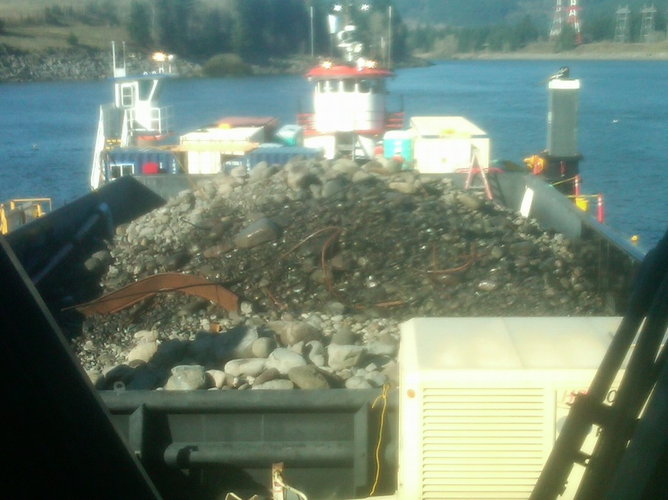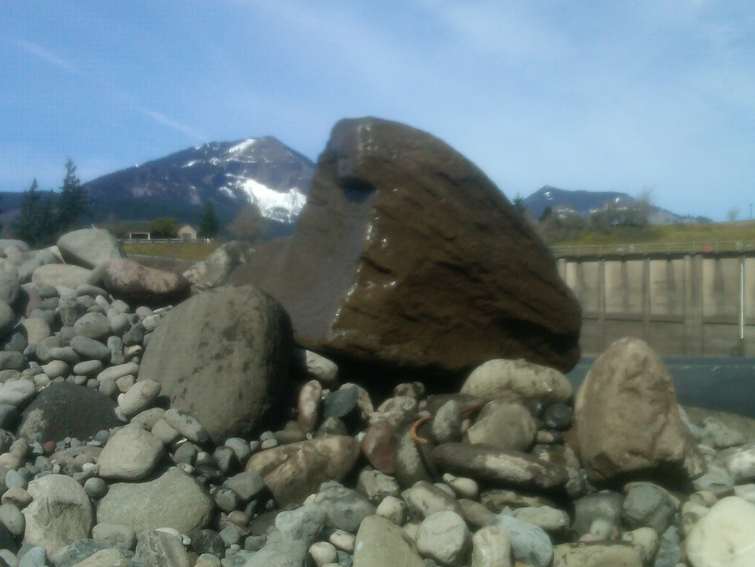

**Photo 6 – BON spillway contract rock removal, 2012.**