CENWP-EC-HD 20 March 2012

MEMORANDUM FOR CENWP-EC-HD [Laurie Ebner]

SUBJECT: Findings from the March 11-16, 2012, ERDC 1:55-Scale Bonneville Spillway General Model site visit (for rock removal work).

Purpose:

1. The purpose of this memorandum is to document the findings from the ERDC 1:55-Scale Bonneville Spillway General Model visit and the flow conditions that were modeled.

Introduction:

2. A model trip was conducted March 11-16, 2012 to use the 1:55-Scale Bonneville Spillway General Model to evaluate the hydraulic conditions that caused material to reposition from downstream of the stilling basin to the stilling basin, determine how rocks entered the stilling basin, and determine if rocks could be hydraulically flushed out of the stilling basin and off of the apron. This effort was in response to rocks being found in the stilling basin and on the concrete apron downstream of the stilling basin in September 2011 hydrosurvey results. The rock in the stilling basin had been removed prior to the model trip.

Discussion:

3. The week of March 12, 2012, rocks of varying size were placed in the 1:55-Scale Bonneville Spillway General Model and the model was run at various flow conditions (Table 1) to evaluate the hydraulic conditions that caused material to reposition from downstream of the stilling basin into the stilling basin. Before each flow configuration, different colored rocks (red, brown, green, and gray) were placed in the model in different locations. The model was then watered up and ran. Due to difficulty seeing the rocks while the model was running, an underwater camera with TV display was used to monitor rock movement. The camera was invaluable in determining the path rocks followed to enter the stilling basin. Following each flow configuration, the flow to the model was shut off, and rock locations were documented. It appears that the rocks that were used in our model testing didn’t represent those in the prototype well. Model rocks entered the stilling basin under flow conditions that prototype rocks did not.

4. The modeling was however very useful in determining the paths rocks took from the downstream of the stilling basin into the stilling basin. Rocks downstream of both north and south ends of the stilling basin were observed making their way into the stilling basin.

Rocks downstream of the south end of the stilling basin moved upstream onto the apron where the apron and bathymetry are essentially level (downstream of bays 15, 16, and 17). The rocks then move lateral to the surface flow, up the apron in front of bays 15, 14, 13, 12, 11, and 10, and gather in the depression in the apron downstream of the pier between bays 9 and 10. At this point the apron and stilling basin floor are nearly the same elevation and the rocks are able to move upstream into bay 9. Most of the rocks then slowly make their way to the south, stopping to mill around in each bay along the way. In some cases, rocks moved south all the way to bay 17. In other cases flow conditions were shown to move rocks from bays 17, 16, and 15 north to bay 14.

Rocks downstream of the north end of the stilling basin generally did not move as much as those to the south and were more difficult to monitor. Most of these rocks would move upstream and stop at the downstream edge of the apron (mostly downstream of bay3). Some, however, would get onto the apron, move laterally up the apron in front of bays 3, 4, and 5 until the apron leveled out even with the stilling basin floor at bay 6, at which point they would move upstream into bay 6. It was difficult to determine a general rock movement pattern out of bay 6.

Figure 1 shows the 1:55-Scale Bonneville Spillway General Model and the typical paths of rocks from each side of the tailrace bathymetry. Figure 2 shows the rocks that were used in the model. Figure 3 shows some rocks that made it into spillway bay 9.

5. An attempt was made to flush rocks out of the model, both out of the stilling basin, and off of the apron downstream of bays 15 and 16. This was done by putting 27,000 cfs per bay through bays 15 and 16 (54,000 cfs total) at a 16 ft tailwater after placing rocks in the stilling basin (on the ogee) in bay 16 and piles on the apron downstream of spillway piers 15/16 and 12/13 (Figure 4). Rocks in the stilling basin milled around and were not flushed out of the stilling basin. Some of the rocks on the apron downstream of pier 15/16 were successfully flushed downstream and off of the apron. The rocks downstream of pier 12/13 did not move during the flushing flow.

Conclusions:

6. Due to the model rock not accurately representing the rock in the prototype, we were unable to determine what flow conditions/patterns might prevent rocks from entering the stilling basin. We were however able to determine the path that rocks follow to enter the stilling basin. Rocks were not hydraulically flushed out of the stilling basin. Some, however, were flushed off of the apron.

Recommendations:

7. Find rocks, marbles, steel/lead balls that represent prototype rocks well in the model, and, knowing what we now know, attempt again to find flow conditions to prevent rocks from moving into the stilling basin. Also consider modeling structural modifications that would prevent rock movement up the apron and into the stilling basin.

Gary Henrie, E.I.T.

Hydraulic Engineer

REVIEW PROCESS:

HD – Reviewed by Laurie Ebner

Table 1: Flow conditions modeled using 1:55-scale Bonneville Spillway General Model



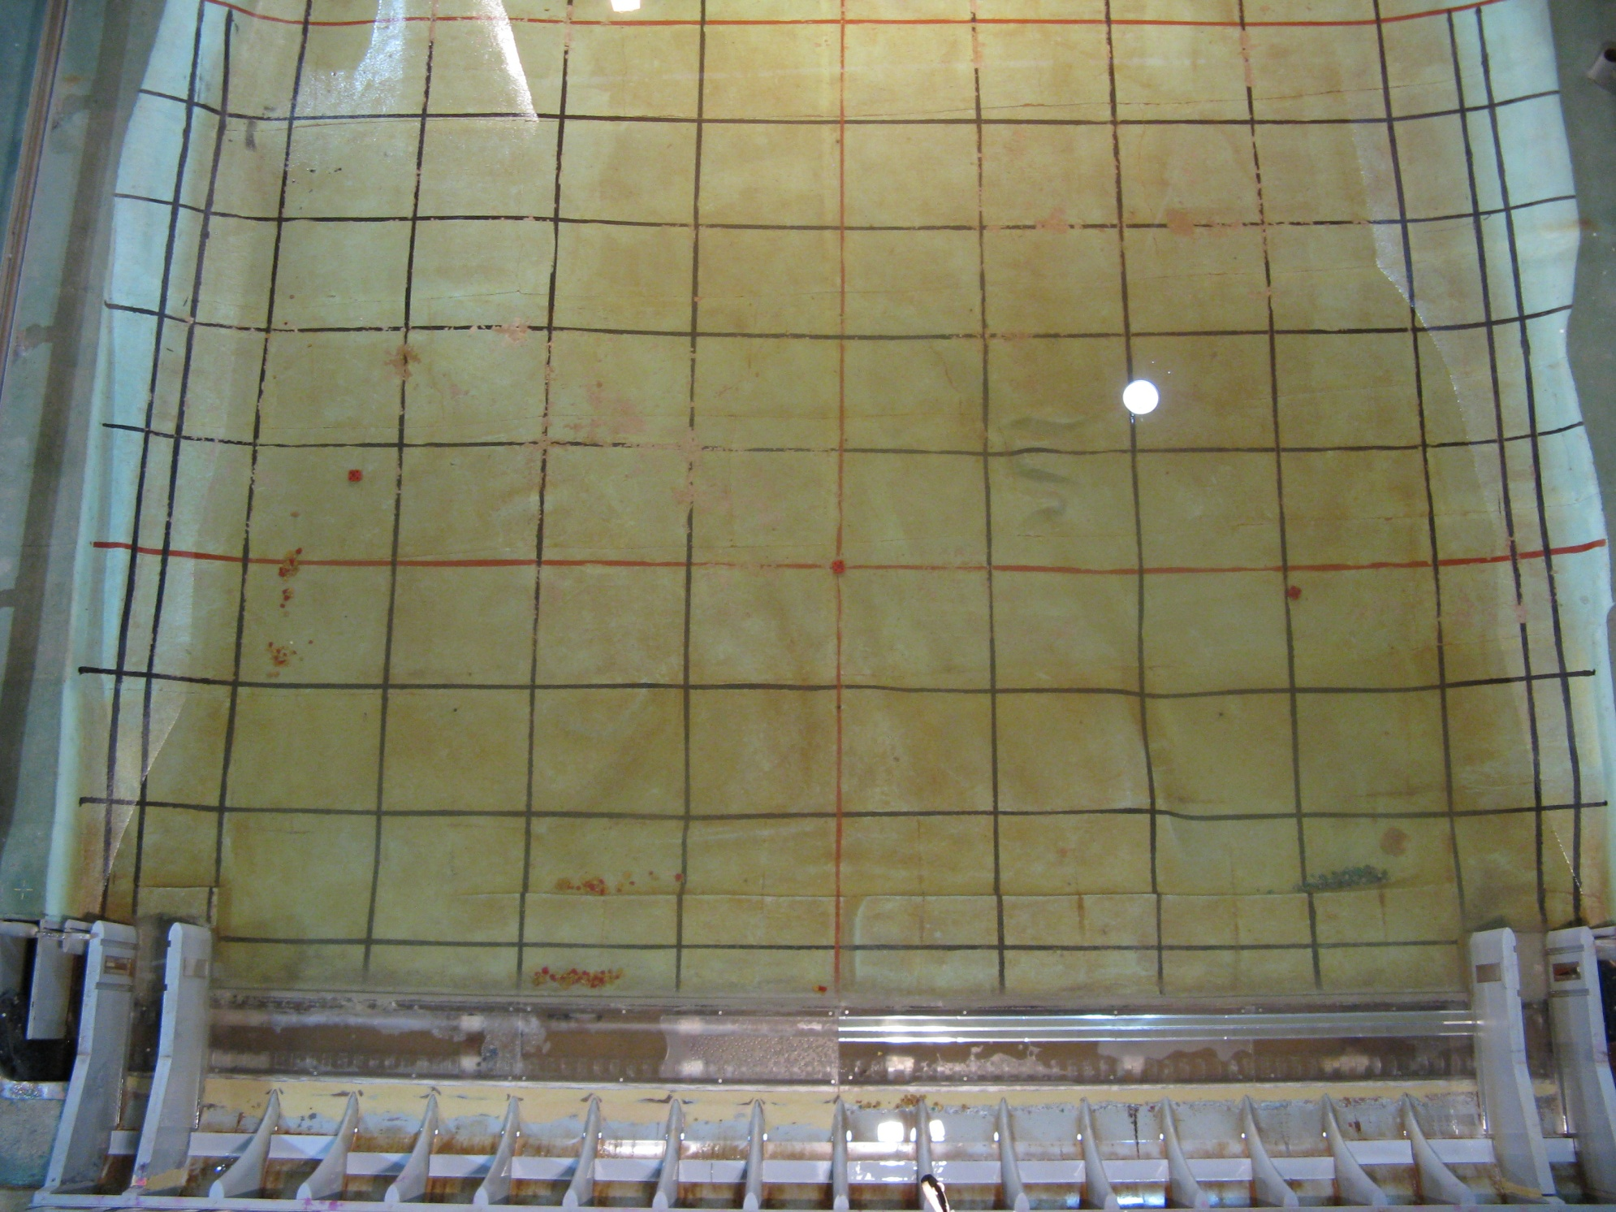

18 17 16 15 14 13 12 11 10 9 8 7 6 5 4 3 2 1

Figure 1: Typical rock movement patterns. Before the model was run, the red and brown rocks were placed at the red circle and the green and gray rocks were placed at the green circle. This photo was taken following the last flow condition listed in Table 1.

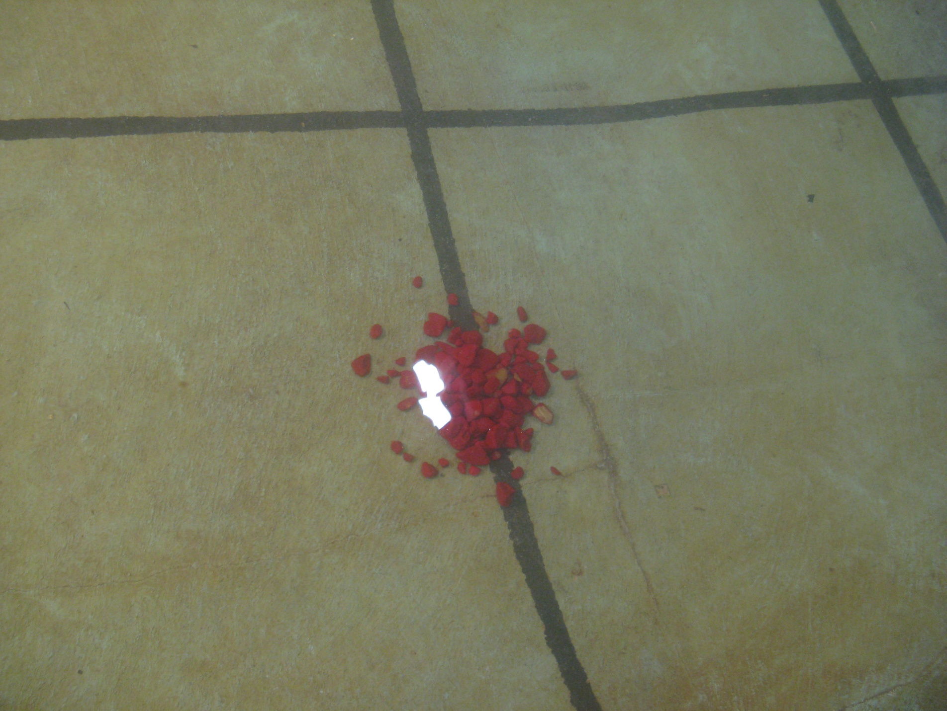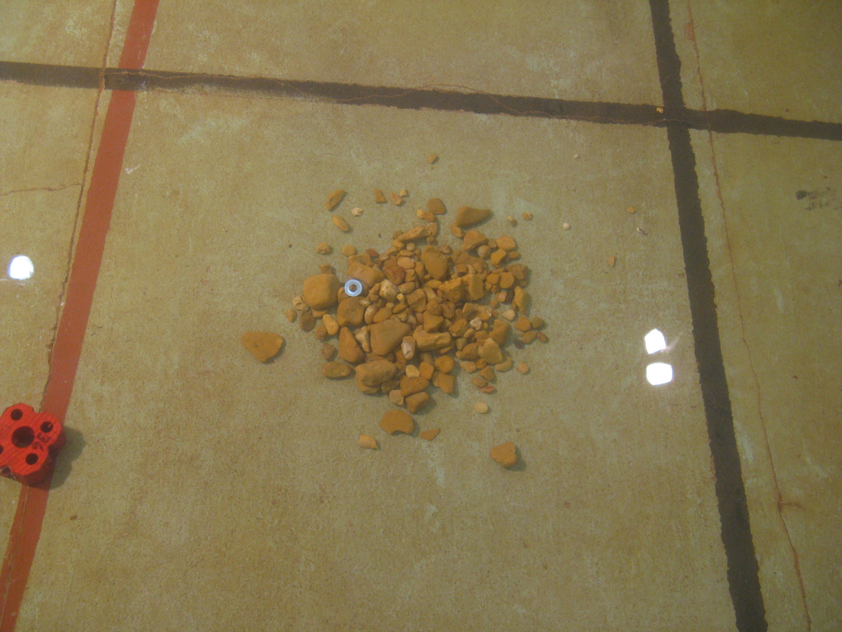

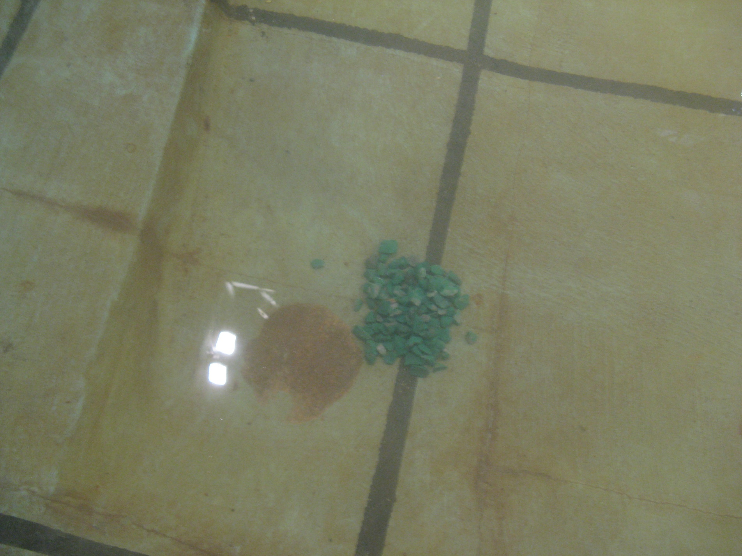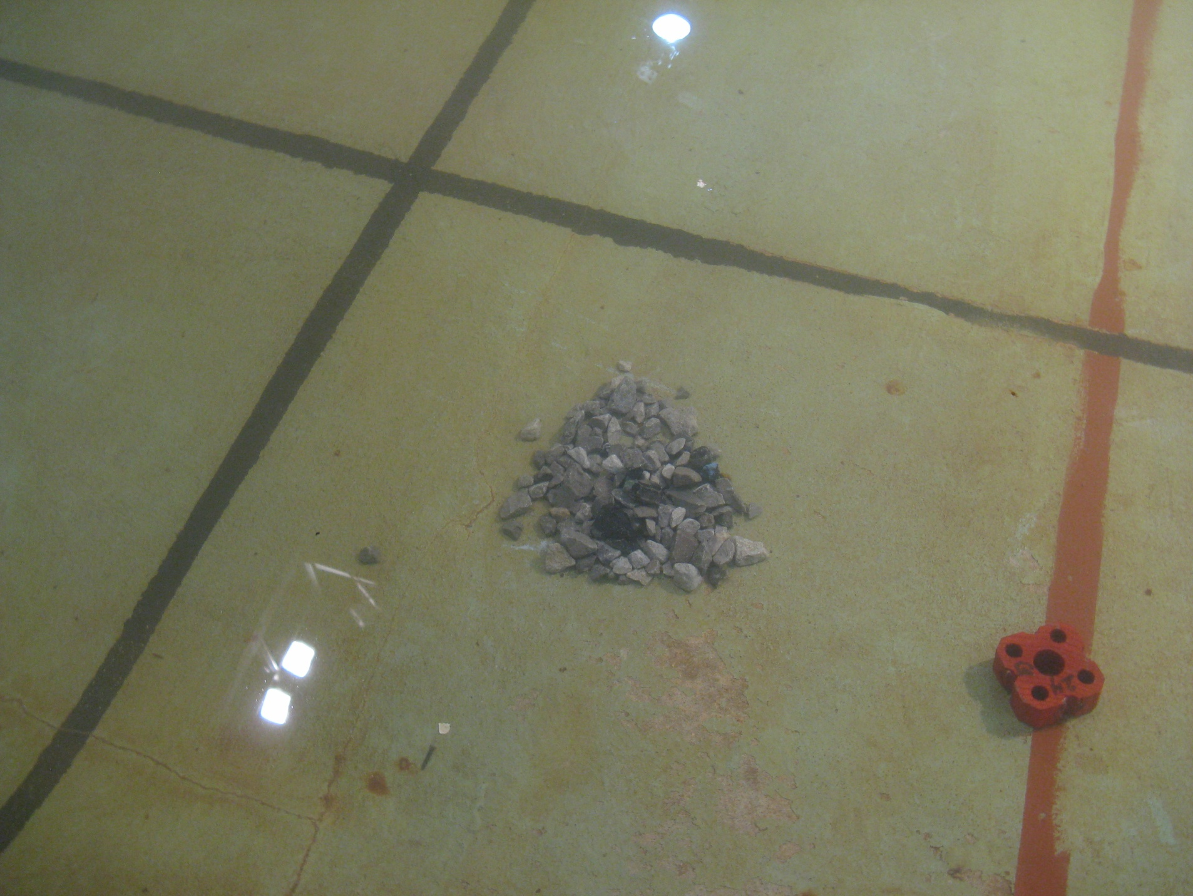

Figure 2: Rocks used in the model. Red and brown rocks were put at the south end of the spillway. Green and gray rocks were put at the north end of the spillway.

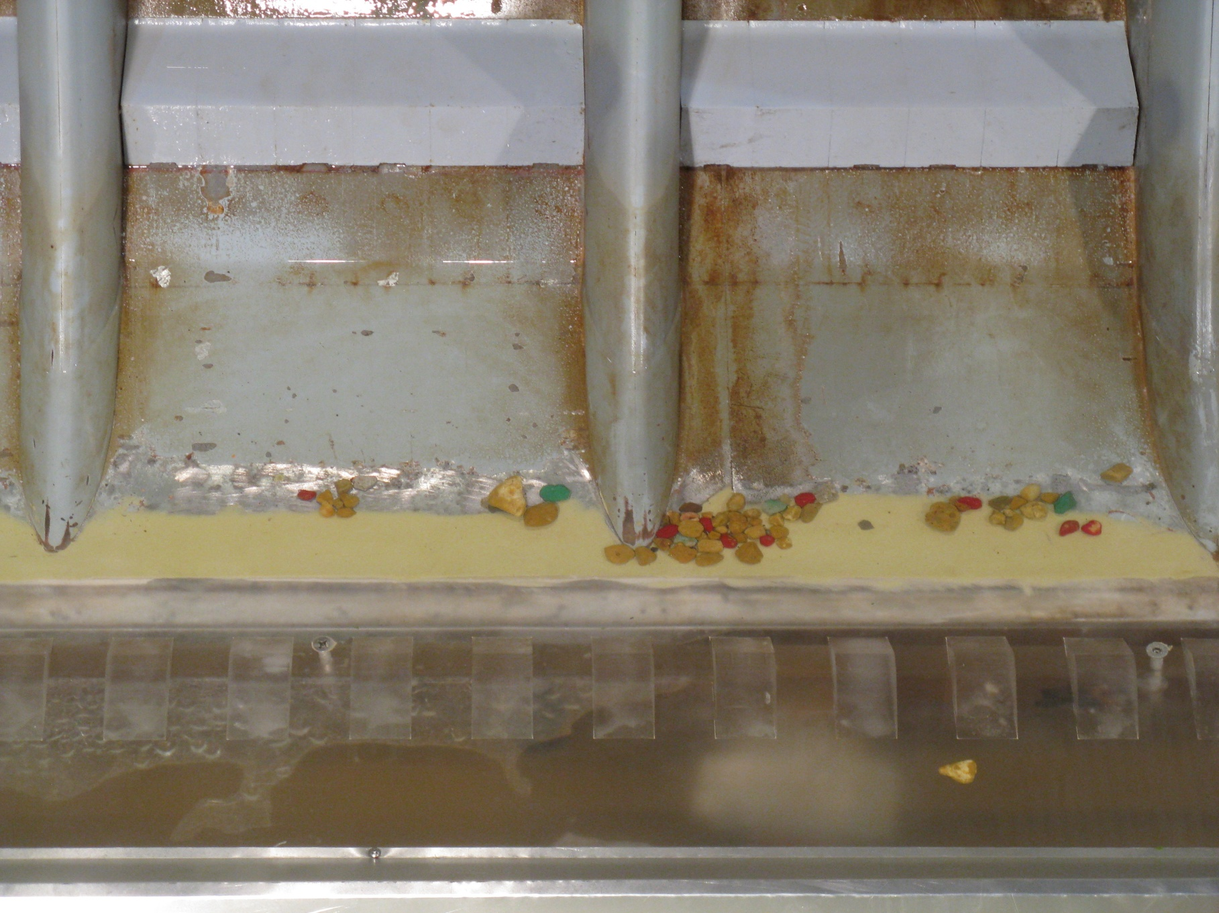

Figure 3: Rocks that made it into bays 8 (left) and 9 (right) following 300 kcfs spill with a continuous baffle block. Mostly red and brown rocks made it to the stilling basin along with some green and gray rocks.

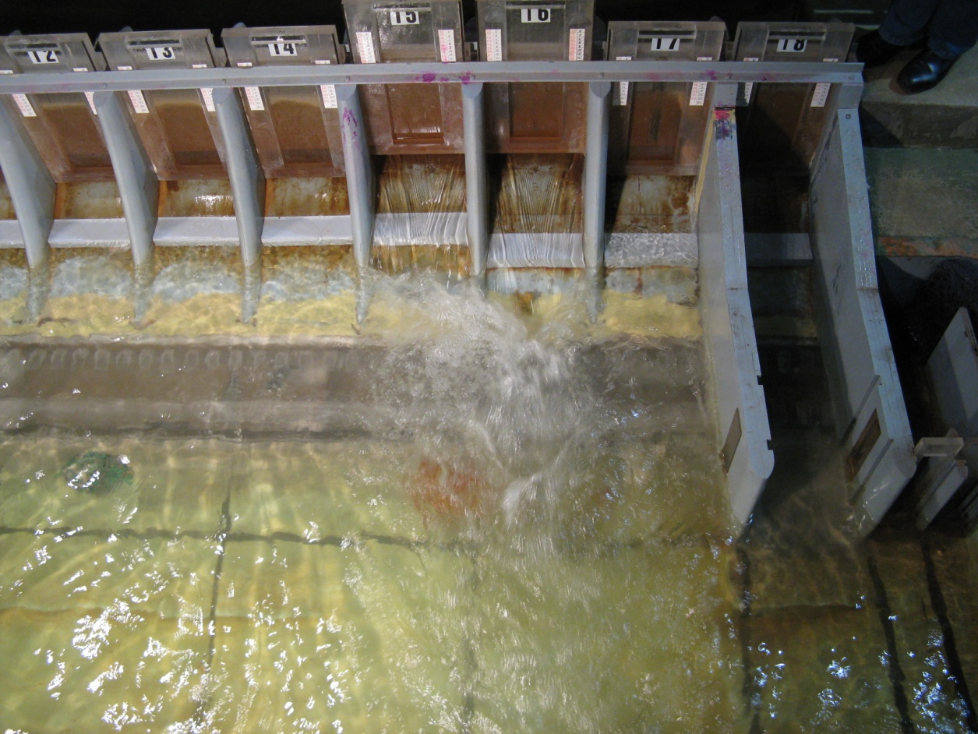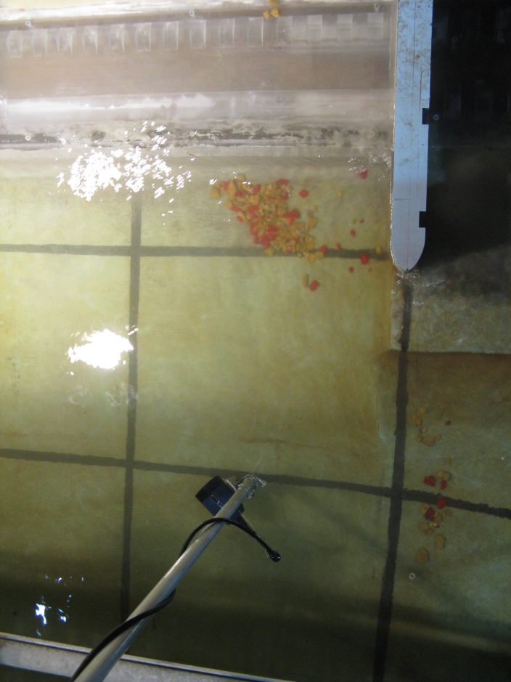

Figure 4: Flushing flow test - rock locations during spill (left) and after spill (right).