
UNITED STATES DEPARTMENT OF COMMERCE
National Oceanic and Atmospheric Administration
NATIONAL MARINE FISHERIES SERVICE
West Coast Region
1201 NE Lloyd Boulevard, Suite 1100
Portland, OR 97232

FILE MEMORANDUM

DATE: 5/13/2015

FROM: Trevor Conder NOAA Fisheries

TO: Sean Tackley and Steve Junke USACE

SUBJECT: NOAA Fisheries recommendation that lamprey openings in FCRPS fish ladders be limited to 1.5 inches or less

NOAA Fisheries biologists have supported the current trend of structural and experimental modifications for lamprey if there is reasonable justification that there will be no impacts to ESA listed migrating salmonids. The 2014 FCRPS BiOp assumes that lamprey modifications at federally operated dams will not result in harm or take to ESA listed salmonids. Regionally supported evaluations have been conducted by the U.S. Army Corps of Engineers on recently built lamprey structures and modifications to verify if these assumptions are indeed correct. Based on these evaluations, there is information indicating that larger lamprey openings (>1.5”) can have the potential to harm ESA listed salmon. Based on these same evaluations, there is a strong record that Pacific lamprey can effectively pass through 1.5” of vertical free space while migrating upstream through fish ladders within the FCRPS. There is little evidence indicating openings greater than 1.5 inches are necessary for lamprey passage, and openings larger than two inches have been documented to lead to potentially harmful interactions for salmon. This memo provides recently available information supporting NOAA’s conclusion that 1.5” of vertical free space adequately meets the intent of the 2014 FCRPS BiOp by ensuring improvements for lamprey do not result in additional impacts to listed salmonids.
The available information suggests lamprey effectively pass a vertical space of 1.5 inches. According to a recent evaluation conducted at McNary Dam from 2011-2014, lamprey passage under the 1.5” raised picketed lead section accounted for a considerable portion (40.9%) of the total count. In 2014, 55% of lamprey passing south shore MCN passed through picket leads at the count station with 81.5% of those swimming under the 1.5” elevated picketed leads which largely mirrored findings in 2011-2013. Researchers noted that lamprey invariably swam without hesitation thorough this gap and continued out of sight, concluding the 1.5” gap was an important passage route. These researchers also note that a large proportion 20-30% of lamprey pass through 1 inch picket lead bar spacing at Bonneville Dam, and raising picket leads 1 inch at Bonneville approximately doubled passage from 23% to 46.7% in 2010 (Thompson et al 2015). This indicates lamprey do not have any apparent difficulty navigating through vertical openings of 1.5 inches or less.
The Walla Walla District, U.S. Army Corps of Engineers modified the upper fish ladder weir sections at McNary/Oregon shore (2010), Ice Harbor and Lower Monumental (2012), and Little Goose and Lower Granite (2013) to reduce delay and improve lamprey passage. Several lamprey orifices were cut into the weirs, flush to the fishway floor and measuring 2.5" tall by 16" wide. Video monitoring was used at orifices to assess lamprey passage and behavior and to monitor migrating salmon and steelhead stocks for potential negative impacts, as evidenced by delay or by attempting to pass lamprey orifices. During video monitoring, researchers viewed video footage and documented salmon approach and interaction with orifices and picket lead openings. According to Thompson et al. (2014) an “interaction” was defined as the fish nosing into or trying to pass the orifice. This behavior indicated the potential to contact the surface of the opening and possibly become injured. The resolution of the underwater cameras in these locations preclude being able to determine if the fish actually made contact with the opening hence the use of the metric “interaction” as a conservative surrogate for potential injury. Examples of video footage demonstrate that an adult salmonid interaction with lamprey orifices could lead to abrasive contact and potential injury (Figure 1.).
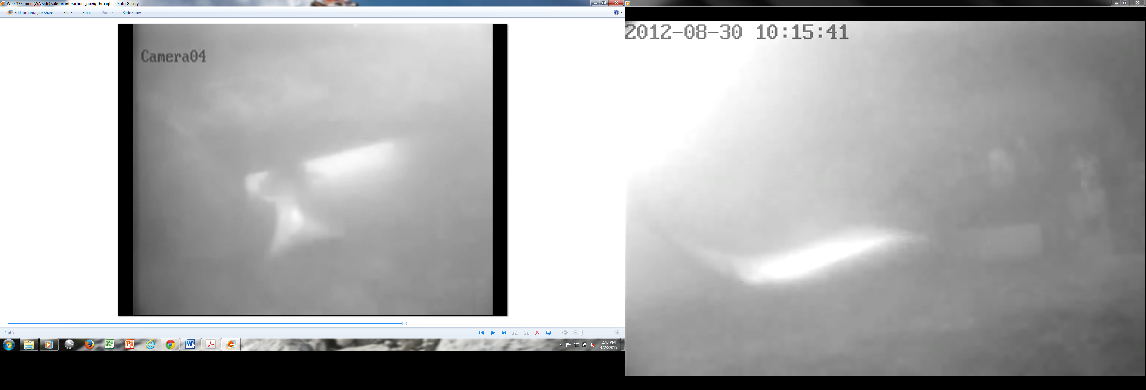
Figure 1. Video clip examples demonstrating separate instances of salmonid interaction with lamprey orifices at FCRPS dams.
During the Corps funded research, salmon and steelhead approach and interaction was observed at the majority of monitored lamprey orifices. Of all monitored species, jack Chinook were most likely to approach and interact with orifice passages at Little Goose Dam (2.5”) with 21.7% of the summer run approaching and 4.7% for the summer run interacting with orifices. For the total summer run, the approach rate was 17.3% and the interaction rate was 3.0%. Adult spring Chinook approached at a lower rate, but an estimated 0.2% of the spring adult run interacted with the orifices. Interactions averaged 6.7 seconds and 1.5 seconds for approaches for the spring run. Researchers concluded migrating stocks of adult Chinook and sockeye salmon and steelhead trout were not remarkably delayed by the presence of lamprey orifices. Previous monitoring of lamprey orifices 2.5 inches or greater at McNary, Ice Harbor, and Lower Monumental dams indicated that sockeye salmon were most likely to interact with orifices in these locations (Thompson et al. 2014).
In June of 2013, an incident occurred at Bonneville Dam that further highlights the need to maintain orifices and picket leads at 1.5 inches or less. Based on information provided in MFR 13BON26, project staff reported they partially dewatered Cascades Island in the morning to remove fish that had made it behind the downstream picket leads. They estimated 30-50 salmonids, mostly sockeye, in that area. The access through the leads was caused by rocks stuck in the picket lead guides, which created a 2” gap on the bottom. The memo notes that the Washington Shore picket leads are raised, for lamprey passage, 1.5" and sockeye have not been seen behind those leads. The project staff suggests that “the safe threshold for lifting leads for lamprey passage may be 1.5".
Based on these sources of information, there is reasonable evidence to suggest that lamprey orifices greater than 1.5” have potential to cause physical injury to ESA listed salmonids since some proportion do interact, pass, or attempt to pass these larger openings. The research to date has not documented negative salmonid interactions with 1.5 inch openings. The available information indicates lamprey have little difficulty and can readily pass a 1.5 inch vertical opening. To maintain effective lamprey passage without affecting ESA listed salmonids, NOAA fisheries recommendation is to limit lamprey orifices in the FCRPS to 1.5 inches or less of vertical free space to effectively pass lamprey while avoiding impacts to ESA listed salmon and steelhead.
References
Thompson , D., Caudill, C., Loge F., 2015. Evaluation of Adult Ladder Modifications to Improve Pacific Lamprey Passage at McNary and Ice Harbor Dams, 2014. Draft Report Submitted to Army Corps of Engineers, Wall Walla District
Thompson , D., Caudill, C., Negrea C., Loge F., 2014 Underwater Video Monitoring of Adult Fish Ladder Modifications to Improve Pacific Lamprey Passage at McNary, Ice Harbor, Little Goose, and Lower Granite Dams, 2013. Final Report Submitted to Army Corps of Engineers, Walla Walla District.

