Fish Passage Plan (FPP) Change Request Form
Change Form # & Title: 17LWG002 – Temperature Monitor Locations in Adult Fishways
Date Submitted: December 31, 2016
Project: All NWW Projects (MCN, IHR, LMN, LGS, LWG)
Requester Name, Agency: Chris Peery, Walla Walla District, USACE
Final Action: APPROVED as Revised 1/26/2017
FPP Section: 2.4.2. Adult Fish Facilities – Fish Passage Season; Figure LWG-1
Justification for Change: Adds location of temperature monitors in the adult fishways to the FPP figure. Also adds language to standardize temperature monitoring at the mainstem ladders to record entrance and exit temperatures and differentials, consistent with language approved for NWP projects.
Proposed Change: Add new section 2.4.2.15. Revise Figure LWG-1 (next page).

2.4.2.15. Fishway Temperature Monitoring.
- From June 1 through September 30, water temperature will be monitored at adult fishway entrances and exits.
  - Temperature monitors shall be placed within 10 meters of all shore-oriented entrances and exits.
  - If possible, the entrance monitor shall be within 1 meter above the ladder floor and at least 10 meters downstream of ladder diffusers to allow for sufficient mixing with surface water.
  - The exit monitor shall be within 1 meter above the ladder floor and above all diffusers to allow for sufficient mixing with surface water.
  - If an existing temperature monitoring location is proposed to be used for either the exit or entrance, it shall be verified that the site accurately reflects water temperature within 10 meters of the entrance or exit.
  - Project Fisheries will submit temperature data to the Fish Passage Center (FPC) on a weekly basis for posting online at: http://www.fpc.org/river/Q_ladderwatertempgraph.php.

Comments:
1/26/2017 FPOM FPP: FPOM requested adding the location of the ladder exit in the forebay. FPOM requested adding monitor location criteria already approved for NWP projects to NWW projects.
Record of Final Action: APPROVED as revised at FPOM FPP meeting 1/26/2017.
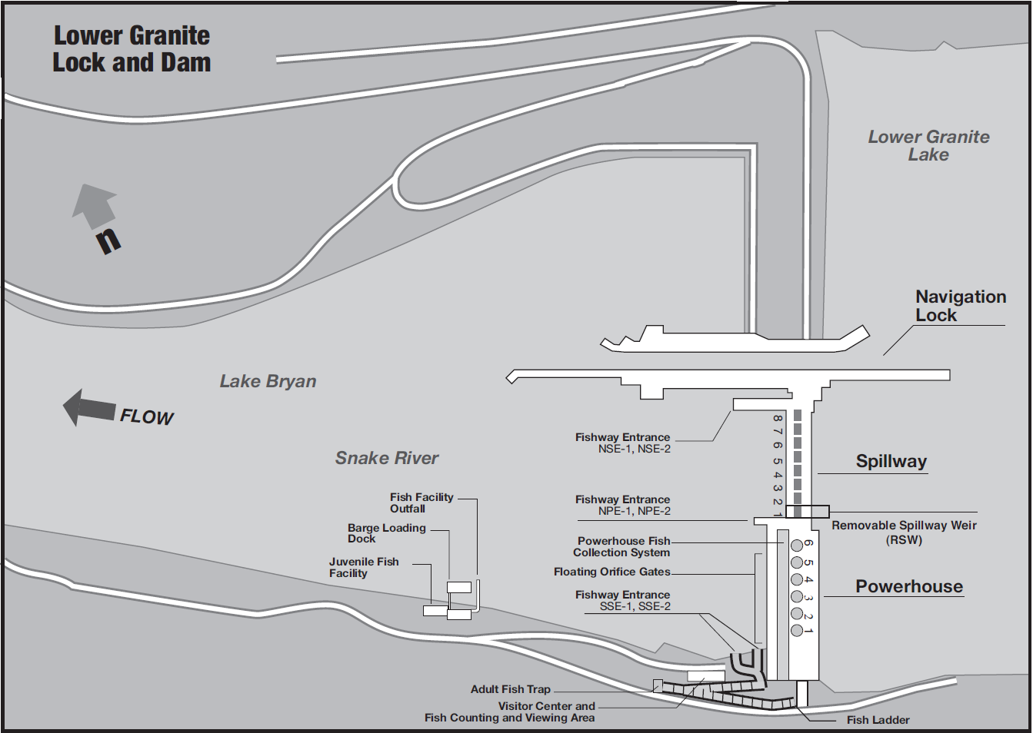

= Fishway Temperature Monitors (6)

Fishway Exit

Figure LWG-1. Lower Granite Lock and Dam General Site Plan.

