Fish Passage Plan (FPP) Change Request Form
Change Form #, Title: 19MCN002 – Temperature Monitor Locations in Adult Fishways
Date Submitted: 12/21/18
Project: MCN
Requester Name, Agency: Denise Griffith, USACE, McNary Dam
Final Action: APPROVED – 2/7/2019

FPP Section: MCN 2.4.2. Adult Fish Facilities – Fish Passage Season; Figure MCN-1

Justification for Change: Update temperature locations on figure 1.

Proposed Change: Revise Figure MCN-1 (see next page).

Comments:

Record of Final Action: Approved at the FPOM FPP meeting on 2/7/2019.
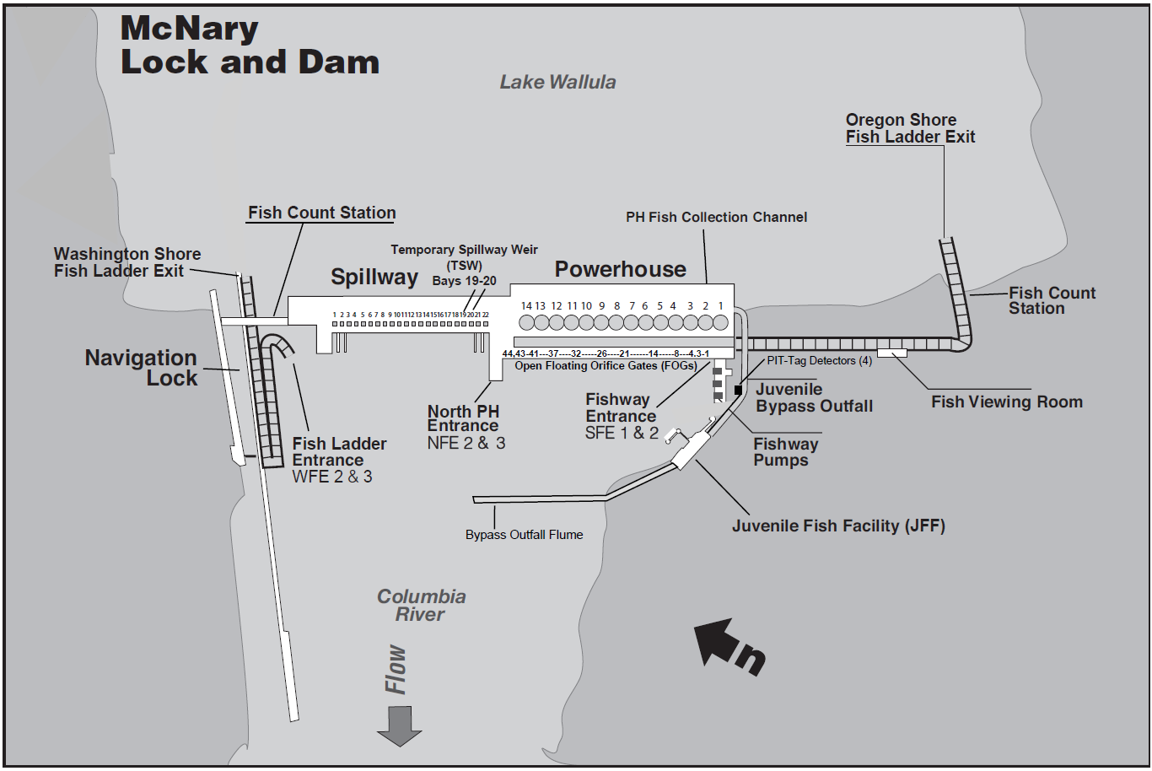

= Fishway Temperature Monitors (8)

= Conductivity Station (2)

Figure MCN-1. McNary Lock & Dam General Site Plan.

