Fish Passage Plan (FPP) Change Request Form
Change Form # & Title: 20AppG001 – Adult Trap Water Supply
Date Submitted: 20 December 2019
Project: Lower Granite Dam
Requester Name, Agency: Chris Peery, USACE NWW OD-T
Final Action: APPROVED 13-FEB-2020
FPP Section: Appendix G – Adult Trap Protocols, section 3. Lower Granite Dam
Justification for Change: Part of the new JFF facility was a water line which was to become the primary supply to the adult trap because it was thought it would provide a cooler source of water. However, during an emergency close of the JFF primary bypass structure (e.g. a debris clog or computer malfunction), all water to the facility would be shut off which would result in loss of water to the adult trap in about 15 minutes. This would place any fish in the trap at risk and so it was decided the JFF supply could not be the primary water supply to the trap, although it can be a backup water supply.
Proposed Change: [see below with edits to existing FPP in track changes]

3.3. Trapping Protocols (Mar 1–Dec 15) – Ladder Water Temperatures < 70°F
3.3.2. During lengthy periods of non-use (two days or more), the facility shall be dewatered or the water supply will be shut down. The trap should be operated with water supply from the adult fishway (diffuser-14) rather than from the juvenile bypass system because of risk of dewatering the adult trap in the event of an emergency close of the JFF primary bypass structure . If freezing weather may cause damage during such a non-use period, the facility will be dewatered.
Comments:
1/23/2020 FPOM FPP Meeting:

Conder asked if this would result in warmer water in the summer compared to the past couple years since the new bypass system was completed.

Peery responded that the project hasn’t yet been able to use the bypass as the primary water supply due to issues the project had to work through with modifications and testing of the new system. So the adult fishway has been the primary source up to this point. Now that the modifications and testing are complete, the plan was to switch to JFF water this year since it may be cooler. However, the issue has now come up with the emergency closure of the JFF, which would dewater the adult trap.

Setter added that an emergency closure of the JFF would dewater the adult trap in about 20 minutes, which is likely before an operator could get to the valve and switch to another source. She confirmed that JFF water can be cooler than water from the fishway cooling pump system, which is why it was originally preferred.

Lorz asked to have this conversation added to the next NWW FFDRWG on 30-JAN.

1/30/2020 NWW FFDRWG Meeting:

Jon Renholds provided more information. During summer months, the water supply in the LWG adult trap can get too warm for fish. The Primary Bypass was identified as a potential source for cooler water to the trap. However, the project has indicated that in an emergency, this bypass system could be dewatered and the valve to switch away from this source is not automated. Consequently, fish could be stranded before an operator could get to the valve (~20 min) and switch to other sources. The project recommends this be considered a secondary source of cooling water.

Conder asked if there’s a way to automate the system so that it switches over in the event of an emergency. Setter responded that the engineers haven’t determined a way to automate, so that an emergency shutoff would result in dewatering and fish stranded in about 15-20 minutes.

Conder asked what the temperature difference would be between the two different sources. Laughery responded that more data need to be collected to see if there is a difference. Lorz thought there is likely a difference so we need to think about a remedy. Renholds responded there can be further evaluation of engineering an automated switch. Laughery added that the spray bar could be shut off to allow colder water into the trap, but we need more data before deciding if that would be helpful. Lorz and Conder prefer not to turn off the spray bar.

ACTION (Renholds and Laughery): 1) collect data to determine temperature difference between the two sources; 2) evaluate potential for automating or another engineering solution.

2/7/2020 email from Chris Peery, COE NWW:
FPOM,
During last month's FPOM and the recent NWW FFDRWG, there was discussion regarding the water supply and temperatures for the adult fish trap at Lower Granite Dam. Attached [see below] is a summary of water temperatures in and near the trap from last fall that will hopefully address some of the questions raised during those discussions.

Lower Granite Dam Adult Fish Trap Water Temperatures.
During 6-12 September 2019, operation of the adult fish trap at Lower Granite Dam was interupted when water temperatures reached 70°F in the trap, as measured by NOAA Fisheries personnel. At that time the water supply to the trap was via the diffuser 14 supply line and the fishway cooling pump and shower were in operation. During recent FFDRWG regional discussions, questions were raised on how water temperatures in the fishway and trap would be affected if the cooling shower was not operating or if the trap water was being provided by the new supply line from the Juvenile Fish Facility. Figure 1 illustrates the water supply routes to fish facilities at Lower Granite Dam. Figure 2 shows locations of the pertinent water temperature monitoring sites at Lower Granite Dam. Figure 3 provides the hourly water temperatures measured at Lower Granite Dam during September 2019.

Summary.—Turning off the fishway cooling shower during the warmest period of September 2019 would have;
-Provided ~1 °F cooler water to the adult trap, likely keeping it below the 70 °F threshold,
-Increased the temperature differential between the trap and the fishway to ~ 2 °F and
-Created another differential between diffuser 14 and fishway exit of 1 - 3 °F.
-We do not yet know what water temperatures would be provided to the adult trap via the JFF supply line.
-We speculate JFF water temperatures may be similar to the turbine discharge which would be ~ 1- 3 °F cooler than the diffuser 14 supply. If true, using the JFF supply to the trap,
-Would produce a commensurate increase of 1- 3 °F in the differential between the trap and fishway.

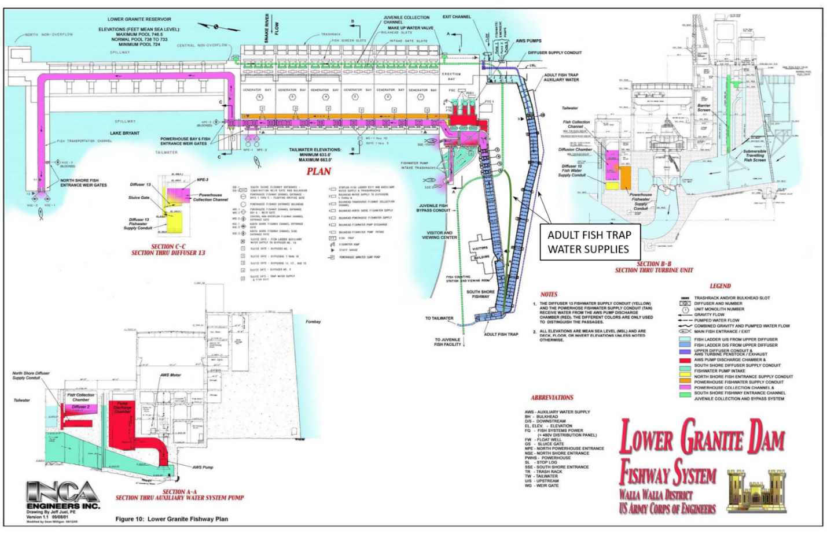
Figure 1. Water supply system for fishway facilities at Lower Granite Dam.
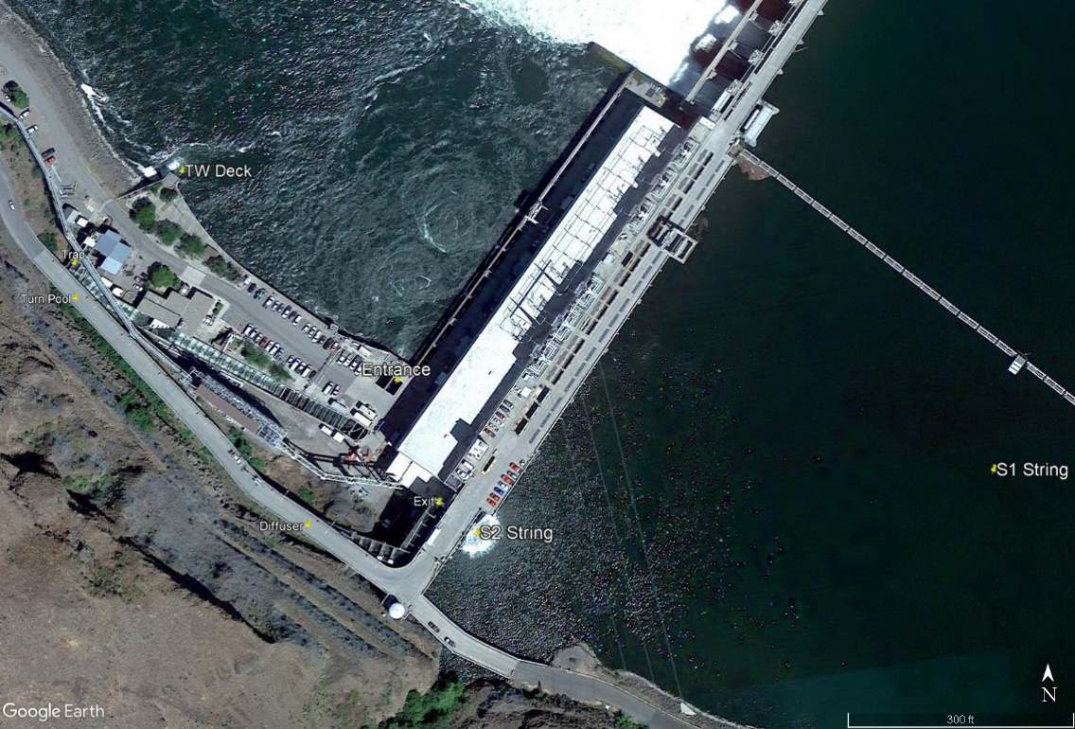
Figure 2. Location of temperature monitoring stations at Lower Granite Dam. String 1 (S1; not correct location) provides the forebay temperature profile not influenced by the fishway cooling pump and shower. String 2 (S2) provides a forebay temperature profile influenced by the fishway cooling pump and shower. Tailwater deck (TW Deck) provides a tailrace temperature influenced by turbine discharge. TW Deck temperatures are slightly cooler than at the fishway entrance site.

Figure 3. Hourly temperatures recorded in the Lower Granite Dam fishway September 2019. See Figure 1 for monitoring locations. Trap temperatures are recorded in the recovery pool of the adult fish trap. Turn pool temperatures are measured in the fishway adjacent to the adult trap and are a mixture of water entering from the forebay at the fishway Exit and flow added to the fishway from diffuser 14. The rectangle indicates the dates (6-12 September) the adult fish trap was out of operation because of warm water temperatures. The brown line shows surface (0.5 m depth) temperatures in the forebay at the S1 string.

Trap temperature without spray bar operating
With the chimney in place, water supplied to diffuser 14 is now pulled from about 20 m deep in the forebay, as measured at the 20 m sensor on the S2 forebay string (blue circles Figure 4). If the spray bar were off, water to the trap would not be mixed with shallower water and would likely be similar to the temperatures recorded at the 20 m depth at the S1 forebay string (green circles, Figure 4). By comparing the two trend lines in Figure 4 we can estimate that water supplied to the trap would have been about 1 °F cooler without the spray bar operating last September.

We also estimated fishway temperatures with and without the cooling pump and shower operating. We found that turn pool temperatures in September could be estimated by averaging the 0.5 m and 20 m temperatures at the S2 string, with a slight weighting of the 20 m temperature. Using the same estimator with the S1 data indicated that the fishway temperatures between the diffuser and turn pool would be similar with and without the cooling pump operating (Figure 5). However, without the shower operating, temperatures between the diffuser and fishway exit would have been warmer, reaching as high as 74 °F during September (see S1 0.5m line in Figure 3). During September, trap temperatures were ~ 1 °F cooler than turn pool temperatures (Figure 6). So we estimate that turning off the cooling pump and shower would have resulted in an ~ 2 °F differential between the Lower Granite Dam trap and turn pool, and an additional 1 - 3 °F differential between the diffuser and fishway exit during the warmest period of September 2019.

2/13/2020 FPOM Meeting: The project will install temperature monitors in the PDW and headbox, pending confirmation from Ryan Laughery that the locations are representative. Temperature information will be added to the weekly reports.

Record of Final Action: Approved at the FPOM meeting on 13-FEB-2020.

